Project Design Phase
Solution Architecture

Date | Sep 29, 2026
Team ID | SWTID-2026-6565
Project Name | AI Fit Track  Daniya Fathima – Team Leader  Aysha Mafazha  Faiza Fathima  Kathija Rayhana
Maximum Marks | 4 Marks

Solution Architecture:
AI Fit Track is a personalized fitness guidance solution that uses AI to understand user goals, activity level and preferences, and provide suitable fitness recommendations.
- Collect user profile, fitness goals and activity preferences.
- Analyze the user inputs and generate personalized recommendations.
- Track progress and use feedback to improve the recommended plan.
- Provide a simple and scalable architecture for secure data handling, AI analysis and user progress tracking.

AI Fit Track – Architecture and Data Flow:

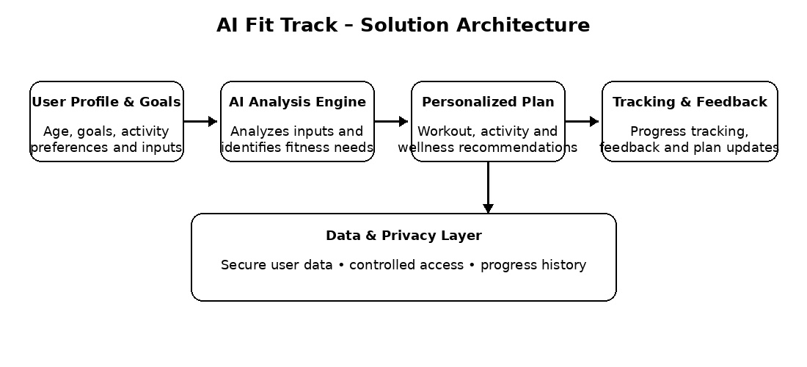
Figure 1: Architecture and data flow of the AI Fit Track solution
Reference: Project concept – AI Fit Track

